Chapter 3: Differentiation

# Section 3.3: Increasing and Decreasing Functions and the First Derivative Test

Determine intervals on which a function is increasing or decreasing.

Apply the First Derivative Test to find relative extrema of a function.

## Increasing and Decreasing Functions

In this section you will learn how derivatives can be used to classify relative extrema as either relative minima or relative maxima. We begin by defining increasing and decreasing functions.

Definitions of Increasing and Increasing Functions.

A function $f$ is increasing on an interval if for any two numbers $x_{1}$ and $x_{2}$ in the interval, $x_{1}<x_{2}$ implies $f\left(x_{1}\right)<f\left(x_{2}\right)$.

A function $f$ is decreasing on an interval if for any two numbers $x_{1}$ and $x_{2}$ in the interval, $x_{1}<x_{2}$ implies $f\left(x_{1}\right)>f\left(x_{2}\right)$.

A function is increasing if, as $x$ moves to the right, its graph moves up, and is decreasing if its graph moves down. For example, the function in Figure 3.15 is decreasing on the interval $\left(−∞,a\right)$, is constant on the interval $\left(a,b\right)$, and is increasing on the interval $\left(b,∞\right)$. As shown in Theorem 3.5 below, a positive derivative implies that the function is increasing; a negative derivative implies that the function is decreasing; and a zero derivative on an entire interval implies that the function is constant on that interval.

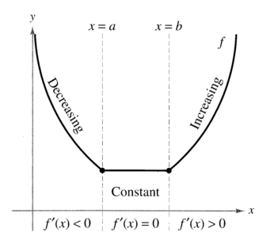

Figure 3.15: The derivative is related to the slope of a function.

## Theorem 3.5: Test for Increasing and Decreasing Functions

Let $f$ be a function that is continuous on the closed interval $\left[a,b\right]$ and differentiable on the open interval .

1. If for all in , then $f$ is increasing on .

2. If for all in , then $f$ is decreasing on .

3. If for all $x$ in $\left(a,b\right)$, then $f$ is constant on $\left[a,b\right]$.

### Proof

To prove the first case, assume that $f'\left(x\right)>0$ for all $x$ in the interval $\left(a,b\right)$ and let $x_{1}<x_{2}$ be any two points in the interval. By the Mean Value Theorem, you know that there exists a number $c$ such that $x_{1}<c<x_{2}$, and

$f'\left(c\right)=\frac{f\left(x_{2}\right)−f\left(x_{1}\right)}{x_{2}−x_{1}}$

Because $f'\left(c\right)>0$ and $x_{2}−x_{1}>0$, you know that

$f\left(x_{2}\right)−f\left(x_{1}\right)>0$

which implies that $f\left(x_{1}\right)<f\left(x_{2}\right)$. So, $f$ is increasing on the interval. The second case has a similar proof (see Exercise 77), and the third case was given as Exercise 58 in Section 3.2.

Note: The conclusions in the first two cases of Theorem 3.5 are valid even if $f'\left(x\right)=0$ at a finite number of x values in $\left(a,b\right)$.

## Example 1: Intervals on Which $f$ is Increasing or Decreasing

Find the open intervals on which $f\left(x\right)=x^{3}−\frac{3}{2}x^{2}$ is increasing or decreasing.

### Solution

Note that $f$ is continuous on the entire real line. To determine the critical numbers of $f$, set $f'\left(x\right)$ equal to zero.

|  |  |
| --- | --- |
| $f\left(x\right)=x^{3}−\frac{3}{2}x^{2}$ | Write original function. |
| $f'\left(x\right)={3x}^{2}−3x=0$ | Differentiate and set $f'\left(x\right)$ equal to $0$. |
| $3\left(x\right)\left(x−1\right)=0$ | Factor. |
| $x=0,1$ | Critical numbers |

Because there are no points for which $f'$ does not exist, you can conclude that $x=0$ and $x=1$ are the only critical numbers. The table summarizes the testing of the three intervals determined by these two critical numbers.

|  |  |  |  |
| --- | --- | --- | --- |
| Interval | $−∞<x<0$ | $0<x<1$ | $1<x<∞$ |
| Test value | $x=−1$ | $x=\frac{1}{2}$ | $x=2$ |
| Sign of $f'\left(x\right)$ | $f'\left(−1\right)=6>0$ | $f'\left(\frac{1}{2}\right)=−\frac{3}{4}<0$ | $f'\left(2\right)=6>0$ |
| Conclusion | Increasing | Decreasing | Increasing |

So, $f$ is increasing on the intervals $\left(−∞,0\right)$ and $\left(1,∞\right)$ and decreasing on the interval $\left(0,1\right)$, as shown in Figure 3.16.

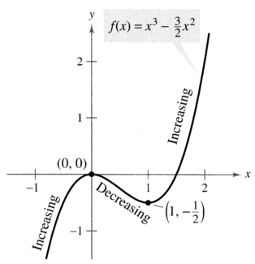

Figure 3.16.

Example 1 gives you one example of how to find intervals on which a function is increasing or decreasing. The guidelines below summarize the steps followed in the example.

Guidelines for Finding Intervals on Which a Function Is Increasing or Decreasing.

Let $f$ be continuous on the interval $\left(a,b\right)$. To find the open intervals on which $f$ is increasing or decreasing, use the following steps.

1. Locate the critical numbers of $f$ in $\left(a,b\right)$, and use these numbers to determine test intervals.

2. Determine the sign of $f'\left(x\right)$ at one test value in each of the intervals.

3. Use Theorem 3.5 to determine whether $f$ is increasing or decreasing on each interval.

These guidelines are also valid if the interval $\left(a,b\right)$ is replaced by an interval of the form $\left(−∞,b\right)$, $\left(a,∞\right)$, or $\left(−∞,∞\right)$.

A function is strictly monotonic on an interval if it is either increasing on the entire interval or decreasing on the entire interval. For instance, the function $f\left(x\right)=x^{3}$ is strictly monotonic on the entire real line because it is increasing on the entire real line, as shown in Figure 3.17 a. The function shown in Figure 3.17 b is not strictly monotonic on the entire real line because it is constant on the interval $\left[0,1\right]$.

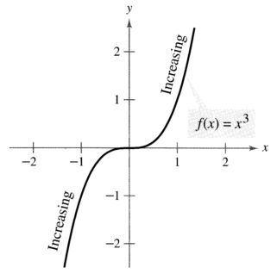

Figure 3.17 a: Strictly monotonic function.

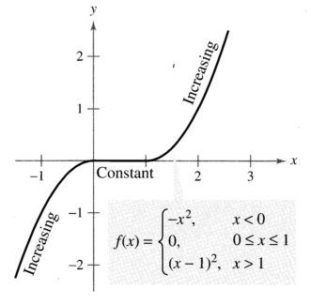

Figure 3.17 b: Not strictly monotonic.